
BILKENT UNIVERSITY
DEPARTMENT OF COMPUTER SCIENCE
CS 223: DIGITAL DESIGN I
LAB 5 INSTRUCTIONS
&
PRELIMINARY REPORT
BERAT BİÇER
21503050
SECTION 3
CS 223 LAB ASSIGNMENT 5
MORSE CODE CONVERTER

Lab dates and times:
Section 1: 5.12.2016 and 12.12.2016 Monday 08:40-12:25
Section 2: 6.12.2016 and 13.12.2016 Tuesday 08:40-12:25
Section 3: 5.12.2016 and 12.12.2016 Monday 13:40-17:25
Section 4: 6.12.2016 and 13.12.2016 Tuesday 13:40-17:25
Section 5: 8.12.2016 and 15.12.2016 Thursday 08:40-12:25
Section 6: 9.12.2016 and 16.12.2016 Friday 08:40-12:25

Location: EA Z04 (in the EA building, straight ahead past the elevators)
Groups: Each student will do the lab individually. Group size = 1

Lab Assignment

In this lab, you are asked to create a Morse coder. Morse code is a method of transmitting text information as a series of on-off tones, lights, or clicks that can be directly understood by a skilled listener or observer without special equipment(taken from Wikipedia).
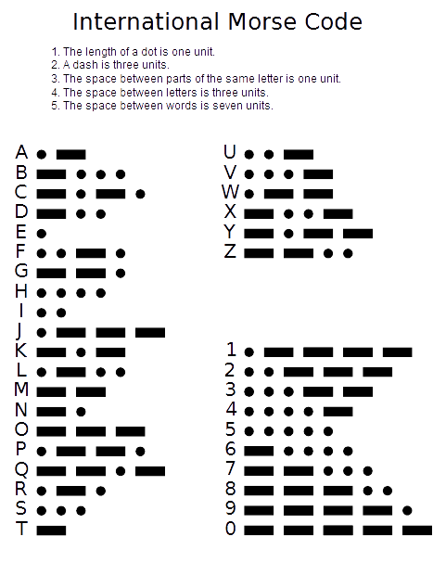
In this lab, your task is to create an FSM that will convert the English alphabet into the Morse code and display them on the leds of BASYS3. Your FSM states should be structured like in the picture below:

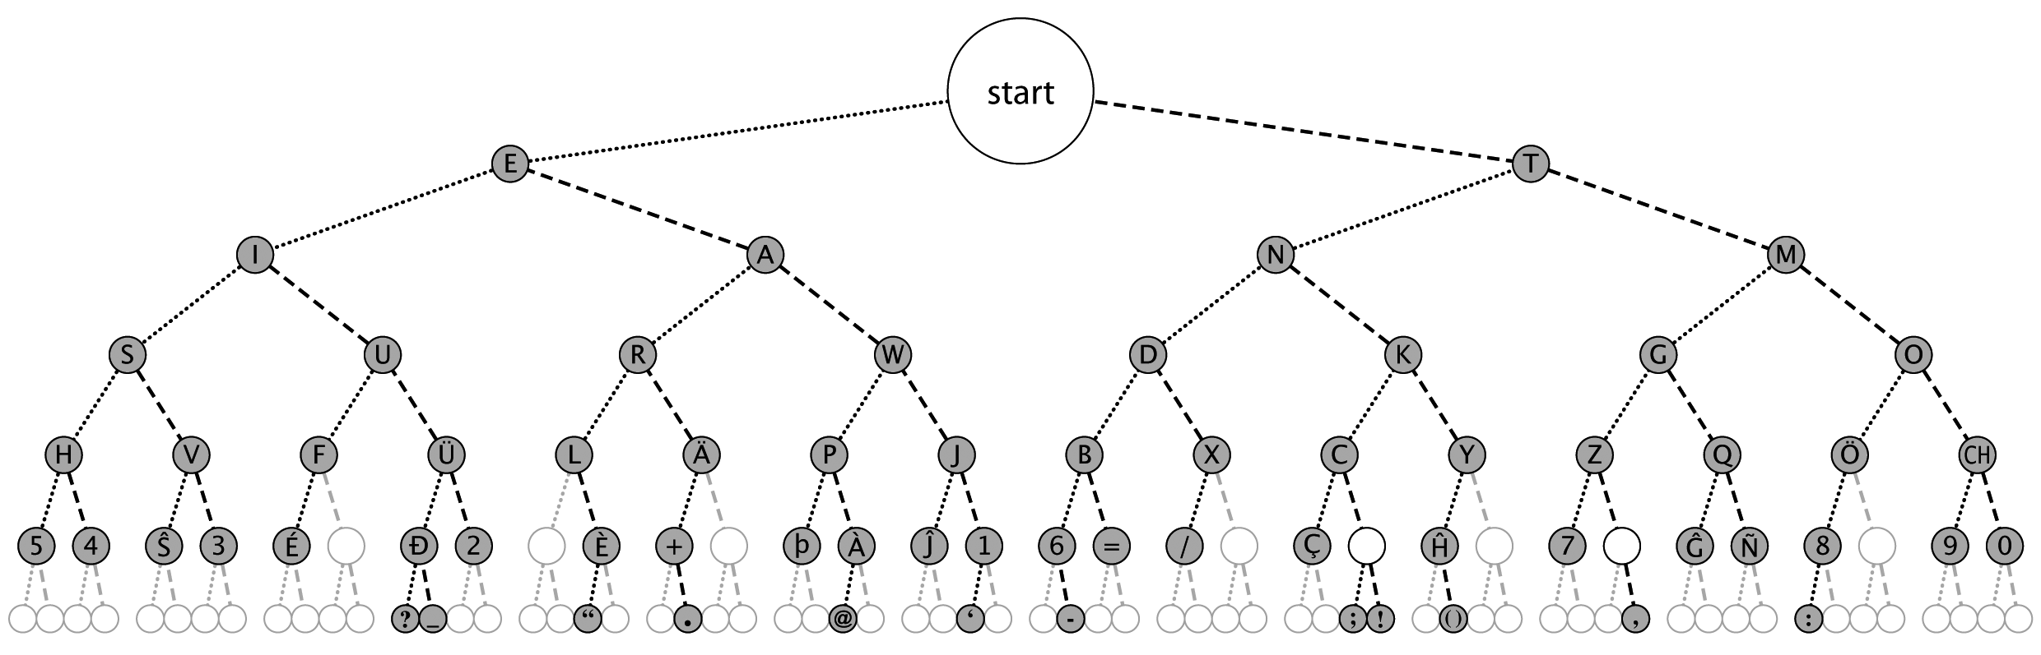
IMPORTANT NOTE:

In this lab, you are asked to implement the Morse code for FIRST 7 STEPS OF THE PICTURE ABOVE. There shouldn't be any more steps, numbers or special characters in your FSM design. You WILL loose points if there is any.

Preliminary Report(35 Points):

All students should be prepared to submit their Preliminary Design Report at the start of their lab section time. You report should contain the following items, each starting at the top of a new page:

a) A cover page which includes the following: course name and code number, the number of the lab, your name and student ID, date, number of your trainer pack.
b) Moore and Mealy FSM for the problem, SystemVerilog codes for the FSM modules
c) Test benches for both FSM designs

The Systemverilog modules are programs, and as with any program, they should be well-structured, well-commented. Use meaningful identifiers, use white space and indentation as appropriate to facilitate understanding, and in summary, your program should be selfdocumenting. If code is difficult to understand, it is not self-documenting! All pages in the report, with the possible exception of a hand-drawn logic diagram, should be printed. You should make a photocopy of the Preliminary Design Report, for you to use during the lab.

Lab Demo(30 Points):

You should come to lab fully prepared. You are advised to arrive with the problem above fully implemented and tested and ready to work. Your grade will be based on the following:

a) You will be asked to do simulation, using the testbench modules you created, for Systemverilog modules in Preliminary work part (b).
b) Implement each of the Systemverilog codes you have designed in the preliminary work. Do the Xilinx design flow (Synthesize, Implement, Create bitstream, and Program the device) to realize your design on the BASYS3 board. When you are convinced that it works correctly, show the physical implementation results to the TA, who will then grade your work.
c) Finally, the TA will ask questions to check your knowledge and understanding of the project and Systemverilog, and you will receive a grade according to your answers.

Submit Your Code for MOSS Similarity Testing

Finally, when you are done and before leaving the lab, you need to upload the file StudentID_SVerilog.txt created in the Implementation with FPGA part. Be sure that the file contains exactly and only the codes which are specifically detailed above. Don’t include the codes which are given to you. If you have multiple files, just copy and paste them in order, one after another inside text file. Check the specifications! Even if you didn’t finish, or didn’t get the SystemVerilog part working, you must submit your code to the Unilica Assignment for similarity checking. Your codes will be compared against all the other codes in all sections of the class, by the MOSS program, to determine how similar it is (as an indication of plagiarism). So be sure that the code you submit is code that you actually wrote yourself! All students must upload their code to the ‘Unilica>Assignment’ specific for your section. Check submission time and don’t miss it before leaving the lab. After taking a backup of your work, don’t forget to delete it from computer. Because students of other sections will work with your system too.

Clean Up

- Clean up your lab station, and return all the parts, wires, the Beti trainer board, etc. Leave your lab workstation.
- 2) CONGRATULATIONS! You are finished with this lab and are one step closer to becoming a computer engineer.

Notes

--Advance work on this lab, and all labs, is strongly suggested.
--Be sure to read and follow the Policies for CS223 labs, posted in Unilica.

Lab Policies

- There are three computers in each row in the lab. Don’t use middle computers, unless you are allowed by lab supervisor.
- You borrow a Lab-board containing the development board, connectors, etc. in the beginning. The lab supervisor takes your signature. When you are done, return it to her, otherwise you will be responsible and lose points.
- Each Lab-board has a number. You must always use the same trainer board pack throughout the semester.
- You must be in the lab, working on the lab, from the time lab starts until you finish and leave. (Bathroom and snack breaks are the exception to this rule). Absence from the lab, at any time, is counted as absence from the whole lab that day.
- No cell phone usage during lab. Tell friends not to call during the lab hours--you are busy learning how digital circuits work!
- Internet usage is permitted only to lab-related technical sites. No Facebook, Twitter, email, news, video games, etc--you are busy learning how digital circuits work !
- If you come to lab later than 20 minutes, you will loose that session completely. ,
- When you are done, DO NOT return IC parts into the IC boxes, where you’ve taken them first. Just put them inside your lab pack box. Lab coordinator will check and return them later.

PRELIMINARY REPORT
MOORE FSM STATE DIAGRAM
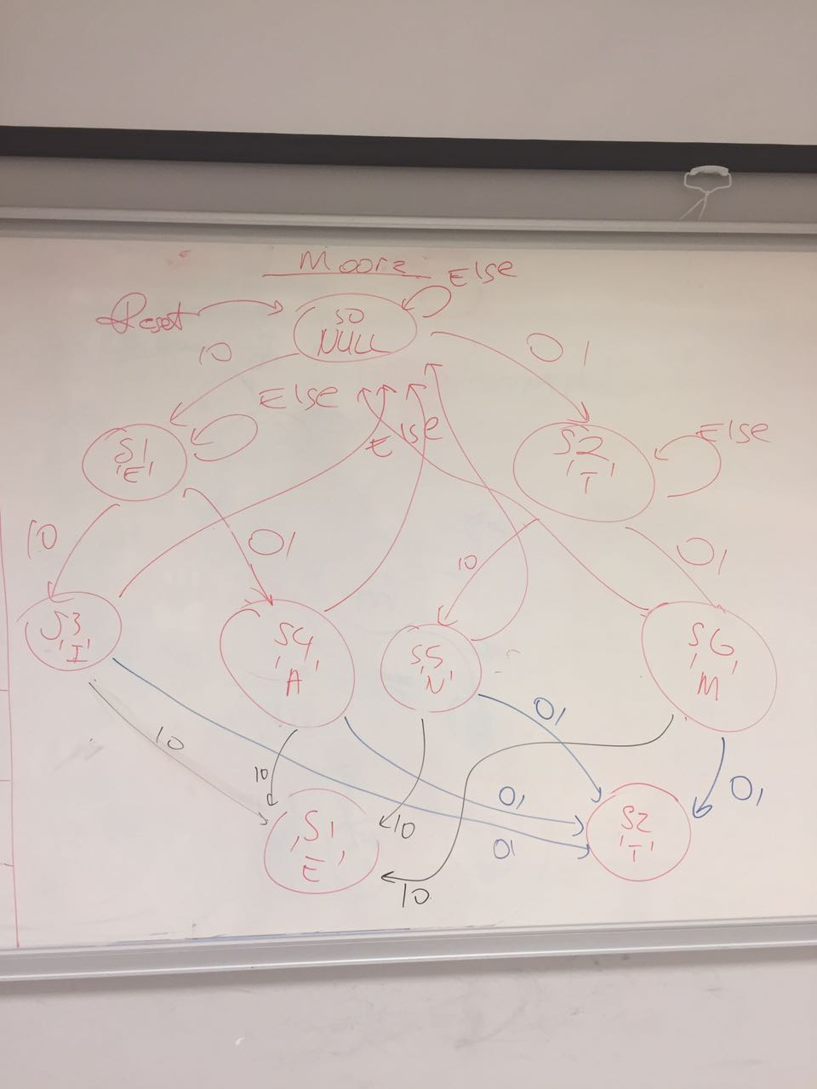

Moore FSM Next State-Output Table
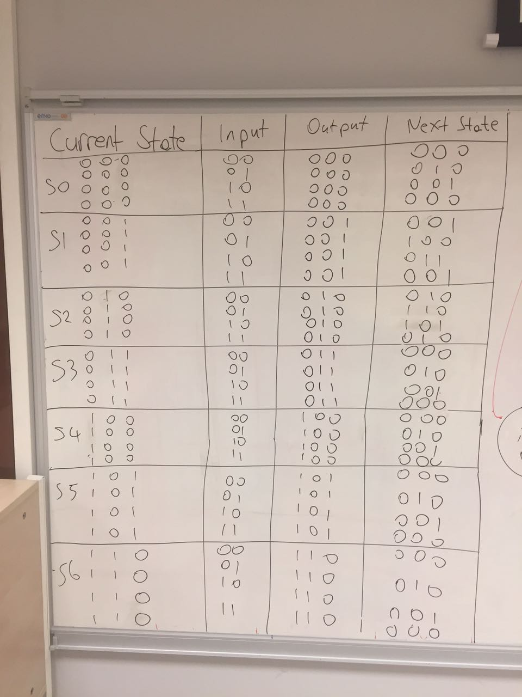

Moore FSM Output Encoding
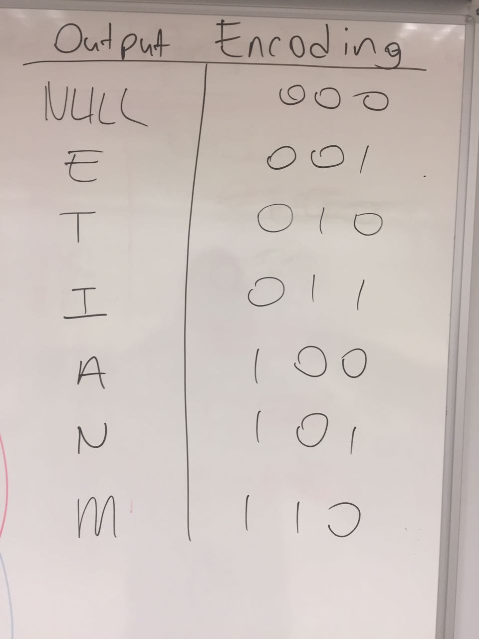
Moore FSM Next State-Output Logics
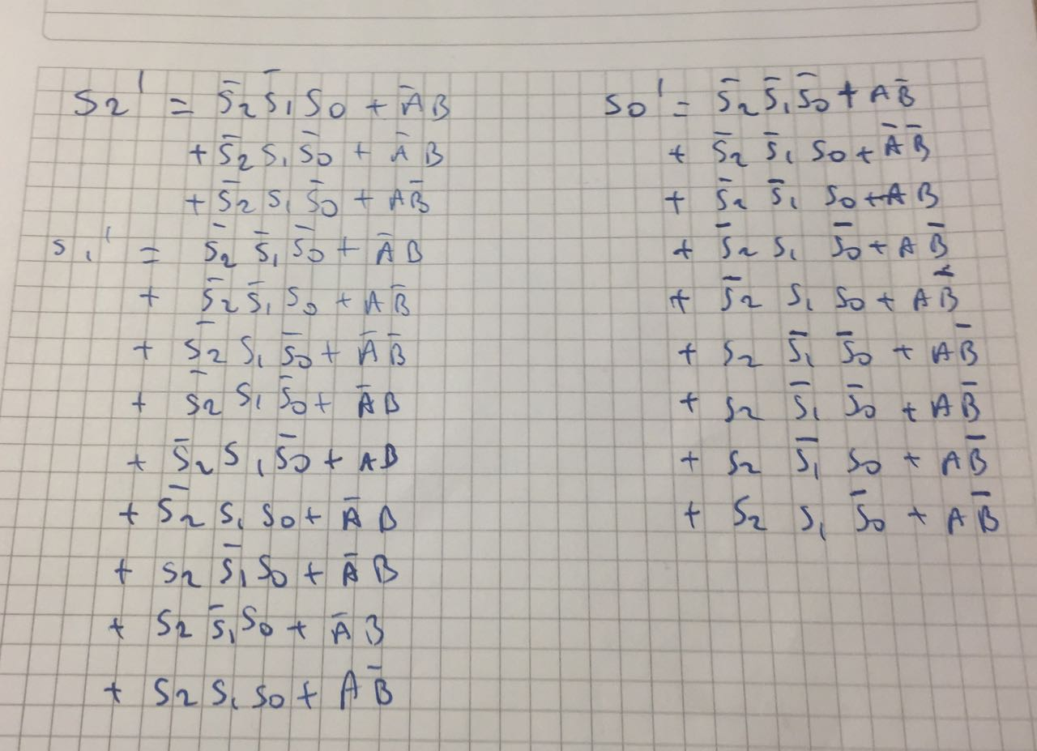

Mealy FSM State Diagram
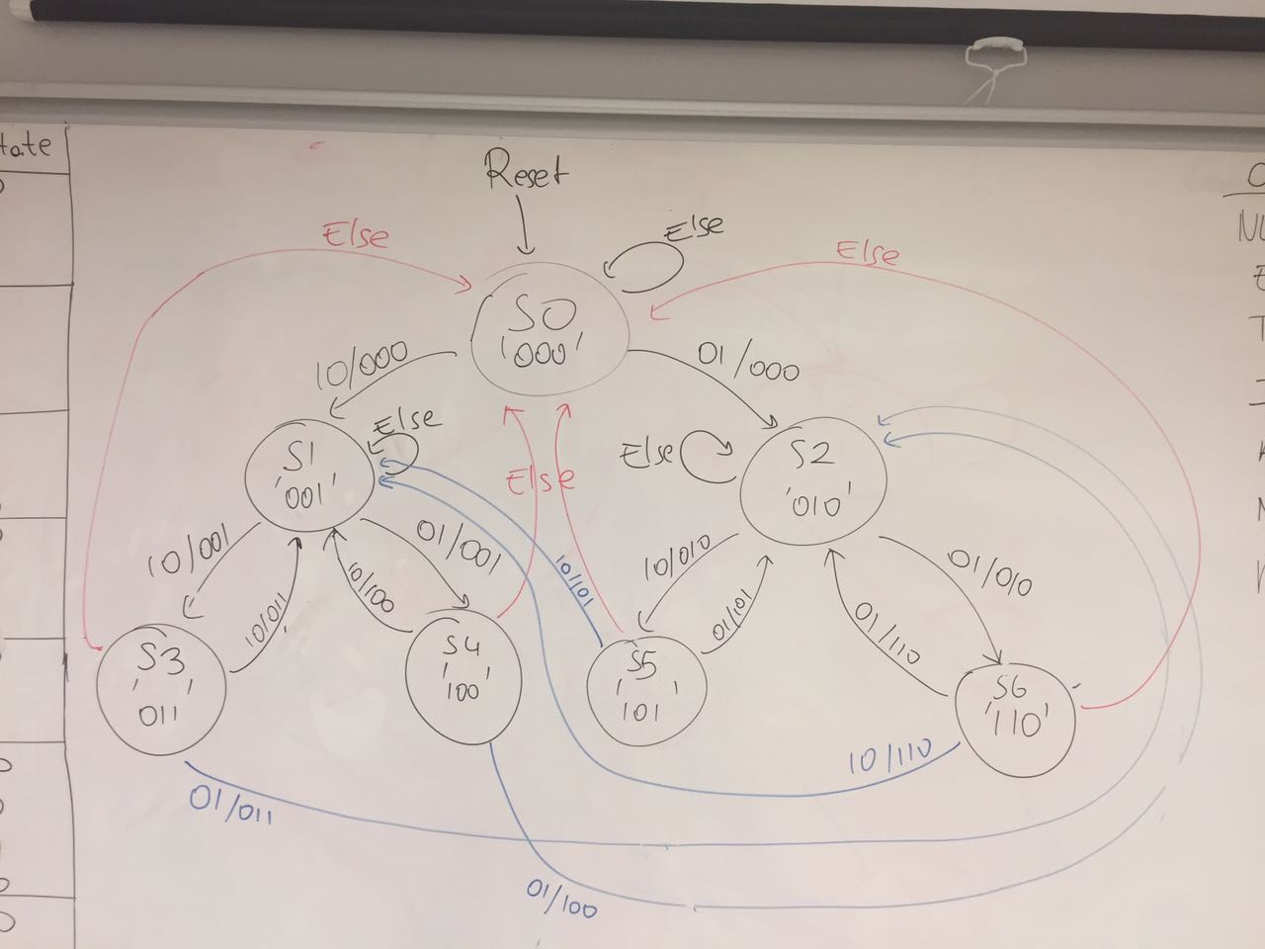
Mealy FSM Output Encoding
Mealy FSM Next State – Output Table
Mealy FSM Next State Logic

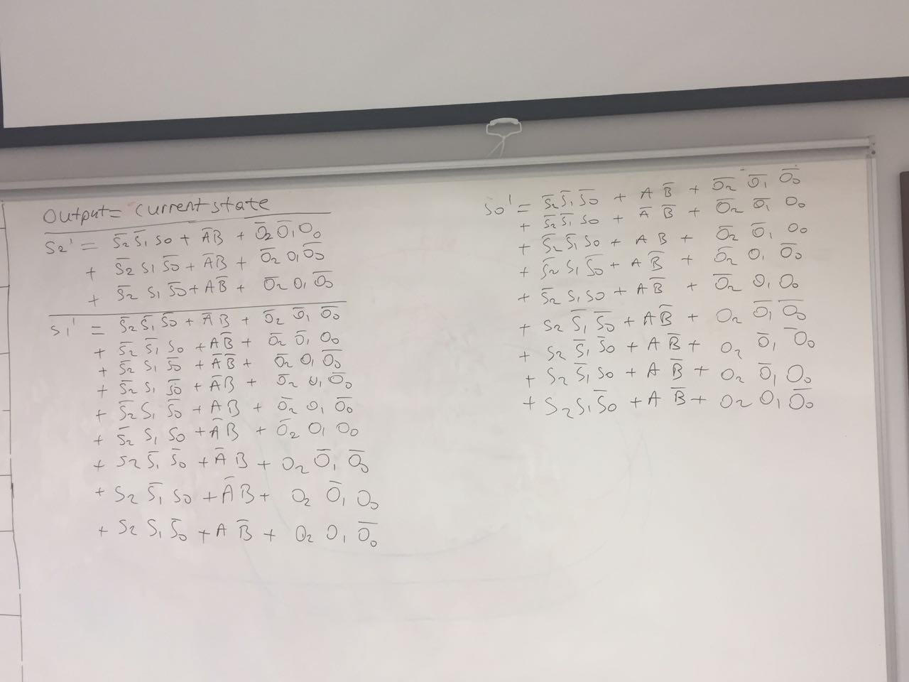
Note: In both FSMs, Output = Current State

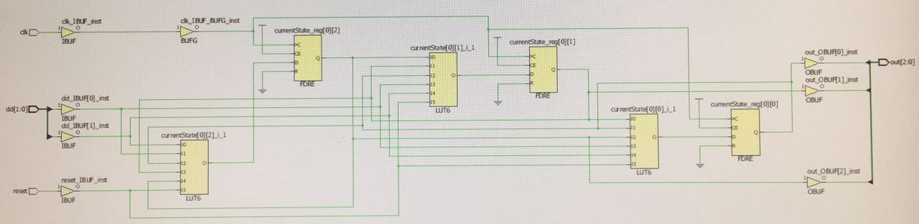
Moore FSM

Mealy FSM
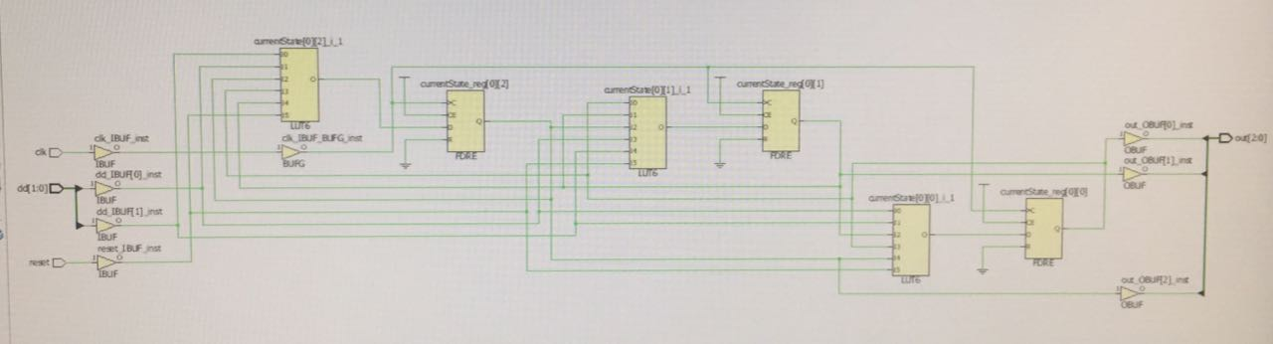
SystemVerilog Codes
Moore FSM
`timescale 1ns / 1ps

module MooreFSM(input logic clk, reset,
input logic [1:0] dd,
output logic [2:0] out);

typedef enum logic [2:0] {S0,S1,S2,S3,S4,S5,S6} statetype;
statetype [2:0] currentState, nextState;

// State Register
always_ff@(posedge clk)
if(reset)
currentState <= S0;
else
currentState <= nextState;

// Next State Logic
always_comb
if(dd == 2'b00) // Input = 00
begin
case(currentState)
3'b000: nextState = currentState;
3'b001: nextState = currentState;
3'b010: nextState = currentState;
3'b011: nextState = 3'b000;
3'b100: nextState = 3'b000;
3'b101: nextState = 3'b000;
3'b110: nextState = 3'b000;
default: nextState = 3'b000;
endcase
end
else if(dd == 2'b01) // Input = 01
begin
case(currentState)
3'b000: nextState = 3'b010;
3'b001: nextState = 3'b100;
3'b010: nextState = 3'b110;
3'b011: nextState = 3'b010;
3'b100: nextState = 3'b010;
3'b101: nextState = 3'b010;
3'b110: nextState = 3'b010;
default: nextState = 3'b000;
endcase
end
else if(dd == 2'b10) // Input = 10
begin
case(currentState)
3'b000: nextState = 3'b001;
3'b001: nextState = 3'b011;
3'b010: nextState = 3'b101;
3'b011: nextState = 3'b001;
3'b100: nextState = 3'b001;
3'b101: nextState = 3'b001;
3'b110: nextState = 3'b001;
default: nextState = 3'b000;
endcase
end
else if(dd == 2'b11) // Input = 11
begin
case(currentState)
3'b000: nextState = currentState;
3'b001: nextState = currentState;
3'b010: nextState = currentState;
3'b011: nextState = 3'b000;
3'b100: nextState = 3'b000;
3'b101: nextState = 3'b000;
3'b110: nextState = 3'b000;
default: nextState = 3'b000;
endcase
end
else
nextState <= S0;

assign out = currentState;

endmodule

Moore FSM TestBench
`timescale 1ns / 1ps

module MooreSim();

logic clk,reset;
logic [1:0] dd,out;

MooreFSM mfsm(clk,reset,dd,out);

initial
begin
reset = 1; #10;
reset = 0; #10;
dd = 2'b01; #10;
dd = 2'b10; #10;
dd = 2'b01; #10;
dd = 2'b10; #10;
dd = 2'b01; #10;
dd = 2'b10; #10;
dd = 2'b00; #10;
dd = 2'b11; #10;
dd = 2'b01; #10;
dd = 2'b10; #10;
dd = 2'b01; #10;
dd = 2'b10; #10;
dd = 2'b01; #10;
dd = 2'b10; #10;
dd = 2'b01; #10;
dd = 2'b10; #10;
dd = 2'b01; #10;
dd = 2'b10; #10;
dd = 2'b01; #10;
dd = 2'b10; #10;
dd = 2'b00; #10;
dd = 2'b11; #10;
dd = 2'b00; #10;
dd = 2'b11; #10;
dd = 2'b00; #10;
dd = 2'b11; #10;
dd = 2'b00; #10;
dd = 2'b11; #10;
dd = 2'b01; #10;
dd = 2'b10; #10;
dd = 2'b00; #10;
dd = 2'b11; #10;
dd = 2'b00; #10;
dd = 2'b11; #10;
dd = 2'b01; #10;
dd = 2'b10; #10;
dd = 2'b00; #10;
dd = 2'b11; #10;
dd = 2'b00; #10;
dd = 2'b11; #10;
dd = 2'b00; #10;
dd = 2'b11; #10;
dd = 2'b00; #10;
dd = 2'b11; #10;
dd = 2'b00; #10;
dd = 2'b11; #10;
dd = 2'b01; #10;
dd = 2'b10; #10;
dd = 2'b01; #10;
dd = 2'b10; #10;
dd = 2'b01; #10;
dd = 2'b10; #10;
dd = 2'b00; #10;
dd = 2'b11; #10;
dd = 2'b01; #10;
dd = 2'b10; #10;
dd = 2'b01; #10;
dd = 2'b10; #10;
dd = 2'b01; #10;
dd = 2'b10; #10;
dd = 2'b01; #10;
dd = 2'b10; #10;
dd = 2'b01; #10;
dd = 2'b10; #10;
dd = 2'b01; #10;
dd = 2'b10; #10;
dd = 2'b00; #10;
dd = 2'b11; #10;
dd = 2'b00; #10;
dd = 2'b11; #10;
dd = 2'b00; #10;
dd = 2'b11; #10;
dd = 2'b01; #10;

end
endmodule

Mealy FSM
`timescale 1ns / 1ps

module MealyFSM(input logic clk, reset,
input logic [1:0] dd,
output logic [2:0] out);

typedef enum logic [2:0] {S0,S1,S2,S3,S4,S5,S6} statetype;
statetype [2:0] currentState, nextState;

// State Register
always_ff@(posedge clk)
if(reset)
currentState <= S0;
else
currentState <= nextState;

// Next State Logic
always_comb
if(dd == 2'b00 && out == currentState) // Input = 00
begin
case(currentState)
3'b000: nextState = currentState;
3'b001: nextState = currentState;
3'b010: nextState = currentState;
3'b011: nextState = 3'b000;
3'b100: nextState = 3'b000;
3'b101: nextState = 3'b000;
3'b110: nextState = 3'b000;
default: nextState = 3'b000;
endcase
end
else if(dd == 2'b01 && out == currentState) // Input = 01
begin
case(currentState)
3'b000: nextState = 3'b010;
3'b001: nextState = 3'b100;
3'b010: nextState = 3'b110;
3'b011: nextState = 3'b010;
3'b100: nextState = 3'b010;
3'b101: nextState = 3'b010;
3'b110: nextState = 3'b010;
default: nextState = 3'b000;
endcase
end
else if(dd == 2'b10 && out == currentState) // Input = 10
begin
case(currentState)
3'b000: nextState = 3'b001;
3'b001: nextState = 3'b011;
3'b010: nextState = 3'b101;
3'b011: nextState = 3'b001;
3'b100: nextState = 3'b001;
3'b101: nextState = 3'b001;
3'b110: nextState = 3'b001;
default: nextState = 3'b000;
endcase
end
else if(dd == 2'b11 && out == currentState) // Input = 11
begin
case(currentState)
3'b000: nextState = currentState;
3'b001: nextState = currentState;
3'b010: nextState = currentState;
3'b011: nextState = 3'b000;
3'b100: nextState = 3'b000;
3'b101: nextState = 3'b000;
3'b110: nextState = 3'b000;
default: nextState = 3'b000;
endcase
end
else
nextState <= S0;

assign out = currentState;

endmodule

Mealy FSM TestBench
`timescale 1ns / 1ps

module MealySim();

logic clk,reset;
logic [1:0] dd,out;

MealyFSM mfsm(clk,reset,dd,out);

initial
begin
reset = 1; #10;
reset = 0; #10;
dd = 2'b01; #10;
dd = 2'b10; #10;
dd = 2'b01; #10;
dd = 2'b10; #10;
dd = 2'b00; #10;
dd = 2'b11; #10;
dd = 2'b01; #10;
dd = 2'b10; #10;
dd = 2'b01; #10;
dd = 2'b10; #10;
dd = 2'b01; #10;
dd = 2'b10; #10;
dd = 2'b01; #10;
dd = 2'b10; #10;
dd = 2'b01; #10;
dd = 2'b10; #10;
dd = 2'b01; #10;
dd = 2'b10; #10;
dd = 2'b00; #10;
dd = 2'b10; #10;
dd = 2'b01; #10;
dd = 2'b10; #10;
dd = 2'b01; #10;
dd = 2'b10; #10;
dd = 2'b01; #10;
dd = 2'b10; #10;
dd = 2'b01; #10;
dd = 2'b10; #10;
dd = 2'b01; #10;
end
endmodule

DISCUSSIONS
- Which of the two state machines is faster in terms of number of required clock cycles for task completion?

Moore FSM is faster because it does not check the output at each step.

- Which one is smaller in terms of circuit size (area)?

Moore FSM is smaller

- Which one is faster in terms of higher achievable clock frequency (shorter critical path in combinational logic)?

Moore FSM is faster because it has less number of gates and circuits

Conclusion
My experiment shows the differences between Mealy and Moore FSM in the following way: State Diagrams and output encodings are very similar im terms of state number and encodings. However, in terms of speed, Mealy FSM is a bad decision since at each input, it also checks the output to move to the next state. That's why the biggest difference in my experiment is speed: Moore FSM is way more faster to operate than Mealy FSM. However, in other meanings there is not much difference. There is one thing that needs to be mentioned, that is, my problem for this assignment is not suitable for showing the exact differences between Mealy and Moore machines since implementation can only be done in a single way.

We have learned QUITE WELL differences between Mealy and Moore machines.

FINAL CODE SUBMISSION
`timescale 1ns / 1ps

module MooreFSM(input logic clk, reset, next,
input logic [1:0] dd,
output logic [6:0] fsm_output);

typedef enum logic [2:0] {S0,S1,S2,S3,S4,S5,S6} statetype;
statetype [2:0] currentState, nextState;

// State Register
always_ff@(posedge clk)
if(reset)
currentState <= S0;
else if(next)
currentState <= nextState;
else
currentState <= currentState;

// Output Logic
always_comb
case(currentState)
3'b000: fsm_output = 7'b0000001;
3'b001: fsm_output = 7'b0000010;
3'b010: fsm_output = 7'b0000100;
3'b011: fsm_output = 7'b0001000;
3'b100: fsm_output = 7'b0010000;
3'b101: fsm_output = 7'b0100000;
3'b110: fsm_output = 7'b1000000;
default: fsm_output = 7'b0000000;
endcase

// Next State Logic
always_comb
if(dd == 2'b00) // Input = 00
begin
case(currentState)
3'b000: nextState = currentState;
3'b001: nextState = currentState;
3'b010: nextState = currentState;
3'b011: nextState = currentState;
3'b100: nextState = currentState;
3'b101: nextState = currentState;
3'b110: nextState = currentState;
default: nextState = currentState;
endcase
end
else if(dd == 2'b01) // Input = 01
begin
case(currentState)
3'b000: nextState = 3'b010;
3'b001: nextState = 3'b100;
3'b010: nextState = 3'b110;
3'b011: nextState = 3'b010;
3'b100: nextState = 3'b010;
3'b101: nextState = 3'b010;
3'b110: nextState = 3'b010;
default: nextState = currentState;
endcase
end
else if(dd == 2'b10) // Input = 10
begin
case(currentState)
3'b000: nextState = 3'b001;
3'b001: nextState = 3'b011;
3'b010: nextState = 3'b101;
3'b011: nextState = 3'b001;
3'b100: nextState = 3'b001;
3'b101: nextState = 3'b001;
3'b110: nextState = 3'b001;
default: nextState = currentState;
endcase
end
else if(dd == 2'b11) // Input = 11
begin
case(currentState)
3'b000: nextState = currentState;
3'b001: nextState = currentState;
3'b010: nextState = currentState;
3'b011: nextState = currentState;
3'b100: nextState = currentState;
3'b101: nextState = currentState;
3'b110: nextState = currentState;
default: nextState = currentState;
endcase
end
else
nextState <= S0;
endmodule

`timescale 1ns / 1ps

module MealyFSM(input logic clk, reset, next,
input logic [1:0] dd,
output logic [6:0] fsm_output);

typedef enum logic [2:0] {S0,S1,S2,S3,S4,S5,S6} statetype;
statetype [2:0] currentState, nextState;

logic [2:0] out;

// State Register
always_ff@(posedge clk)
if(reset)
currentState <= S0;
else if(next)
currentState <= nextState;
else
currentState <= currentState;

// Output Logic
always_comb
begin
case(currentState)
3'b000: fsm_output = 7'b0000001;
3'b001: fsm_output = 7'b0000010;
3'b010: fsm_output = 7'b0000100;
3'b011: fsm_output = 7'b0001000;
3'b100: fsm_output = 7'b0010000;
3'b101: fsm_output = 7'b0100000;
3'b110: fsm_output = 7'b1000000;
default: fsm_output = 7'b0000000;
endcase

out <= currentState;
end
// Next State Logic
always_comb
if(dd == 2'b00 && out == currentState) // Input = 00
begin
case(currentState)
3'b000: nextState = currentState;
3'b001: nextState = currentState;
3'b010: nextState = currentState;
3'b011: nextState = currentState;
3'b100: nextState = currentState;
3'b101: nextState = currentState;
3'b110: nextState = currentState;
default: nextState = currentState;
endcase
end
else if(dd == 2'b01 && out == currentState) // Input = 01
begin
case(currentState)
3'b000: nextState = 3'b010;
3'b001: nextState = 3'b100;
3'b010: nextState = 3'b110;
3'b011: nextState = 3'b010;
3'b100: nextState = 3'b010;
3'b101: nextState = 3'b010;
3'b110: nextState = 3'b010;
default: nextState = currentState;
endcase
end
else if(dd == 2'b10 && out == currentState) // Input = 10
begin
case(currentState)
3'b000: nextState = 3'b001;
3'b001: nextState = 3'b011;
3'b010: nextState = 3'b101;
3'b011: nextState = 3'b001;
3'b100: nextState = 3'b001;
3'b101: nextState = 3'b001;
3'b110: nextState = 3'b001;
default: nextState = currentState;
endcase
end
else if(dd == 2'b11 && out == currentState) // Input = 11
begin
case(currentState)
3'b000: nextState = currentState;
3'b001: nextState = currentState;
3'b010: nextState = currentState;
3'b011: nextState = currentState;
3'b100: nextState = currentState;
3'b101: nextState = currentState;
3'b110: nextState = currentState;
default: nextState = currentState;
endcase
end
else
nextState <= S0;
endmodule

`timescale 1ns / 1ps

module MooreSim();

logic clk,reset,next;
logic [1:0] dd;
logic [6:0] out;

MooreFSM mfsm(clk,reset,next,dd,out);

always
begin
clk = ~clk; #5;
end

initial
begin
clk = 1; #10;
reset = 1; #10;
reset = 0; #10;

next = 1; # 200;

dd = 2'b01; #10;
dd = 2'b01; #10;
dd = 2'b01; #10;

reset = 1; #10;
reset = 0; #10;

dd = 2'b10; #10;
dd = 2'b10; #10;
dd = 2'b10; #10;

reset = 1; #10;
reset = 0; #10;

dd = 2'b01; #10;
dd = 2'b01; #10;
dd = 2'b01; #10;

reset = 1; #10;
reset = 0; #10;

dd = 2'b10; #10;
dd = 2'b10; #10;
dd = 2'b10; #10;
end

endmodule

`timescale 1ns / 1ps

module MealySim();

logic clk,reset,next;
logic [1:0] dd;
logic [6:0] out;

MealyFSM mfsm(clk,reset,next,dd,out);

always
begin
clk = ~clk; #5;
end

initial
begin
clk = 1; #10;
reset = 1; #10;
reset = 0; #10;

next = 1; # 200;

dd = 2'b01; #10;
dd = 2'b01; #10;
dd = 2'b01; #10;

reset = 1; #10;
reset = 0; #10;

dd = 2'b10; #10;
dd = 2'b10; #10;
dd = 2'b10; #10;

reset = 1; #10;
reset = 0; #10;

dd = 2'b01; #10;
dd = 2'b01; #10;
dd = 2'b01; #10;

reset = 1; #10;
reset = 0; #10;

dd = 2'b10; #10;
dd = 2'b10; #10;
dd = 2'b10; #10;
end

endmodule

# Clock signal
set_property PACKAGE_PIN W5 [get_ports clk]
set_property IOSTANDARD LVCMOS33 [get_ports clk]
create_clock -add -name sys_clk_pin -period 10.00 -waveform {0 5} [get_ports clk]

# Switches
set_property PACKAGE_PIN V17 [get_ports {reset}]
set_property IOSTANDARD LVCMOS33 [get_ports {reset}]

set_property PACKAGE_PIN V16 [get_ports {dd[0]}]
set_property IOSTANDARD LVCMOS33 [get_ports {dd[0]}]

set_property PACKAGE_PIN W16 [get_ports {dd[1]}]
set_property IOSTANDARD LVCMOS33 [get_ports {dd[1]}]

set_property PACKAGE_PIN W17 [get_ports {next}]
set_property IOSTANDARD LVCMOS33 [get_ports {next}]

set_property PACKAGE_PIN U16 [get_ports {fsm_output[0]}]
set_property IOSTANDARD LVCMOS33 [get_ports {fsm_output[0]}]
set_property PACKAGE_PIN E19 [get_ports {fsm_output[1]}]
set_property IOSTANDARD LVCMOS33 [get_ports {fsm_output[1]}]
set_property PACKAGE_PIN U19 [get_ports {fsm_output[2]}]
set_property IOSTANDARD LVCMOS33 [get_ports {fsm_output[2]}]
set_property PACKAGE_PIN V19 [get_ports {fsm_output[3]}]
set_property IOSTANDARD LVCMOS33 [get_ports {fsm_output[3]}]
set_property PACKAGE_PIN W18 [get_ports {fsm_output[4]}]
set_property IOSTANDARD LVCMOS33 [get_ports {fsm_output[4]}]
set_property PACKAGE_PIN U15 [get_ports {fsm_output[5]}]
set_property IOSTANDARD LVCMOS33 [get_ports {fsm_output[5]}]
set_property PACKAGE_PIN U14 [get_ports {fsm_output[6]}]
set_property IOSTANDARD LVCMOS33 [get_ports {fsm_output[6]}]

